Post Graduate Programme in Management

Batch: PGPM 2023-25

Decision Analytics for Managers
Case: KKR’s Squad Selection Dilemma: A Performance-Driven Analysis

Group: 2 - Team No.: 10

Name | Roll No
Babitha Raju | 2301013
Dia Majumder | 2301021
Chiradip Lahiri | 2301258
Debashruti Bhattacharjee | 2301259
J Gowrishanker | 2301342

KKR IPL Squad Selection - Solution

Business Objective:
To select the optimal squad for Kolkata Knight Riders for IPL 2025, based on their past season’s performance.

Assumptions:
- The players will be bought at the same price as last year in the auctions.
- All the players we have considered will be available during the auctions.
- The weights of the criteria were given after deliberating on its importance.
- The amount available for retention of 6 players from the current squad will br 63 Crores.
- Out of 6 players retained, 2 players will be there from each category ie, batsmen, bowlers, and all-rounders

Methodology and Tools Used:
DEA (Data Envelopment Analysis)
TOPSIS (Technical for Order of Preference by Similarity to Ideal Solution)
BIP (Binary Integer Programming)

Data:
We have the following data for the given case:
- 22 Indian/ Domestic Players who played for KKR for IPL 2024 and their respective categories
- Inputs: Age, Matches Played, Batting Strike Rate, Bowling Strike Rate, Economy
- Output: Catches, Runs Scored, Wickets, Impact Points

For TOPSIS:
- Cost Metrics: Age, Bowling Strike Rate, Cost, Bowling Average, Economy
- Benefit Metrics: Matches Played, Batting Strike Rate, Batting Average, Catches, Runs Scored, Wickets, Impact Points

The Process:

DEA was run separately for 3 categories of players - batsmen, bowlers, and all-rounders - to find which of the players were efficient. Input-oriented DEA was performed, with Constant Returns to Scale.

After the DEA analysis, we found the following players to be on the efficient frontier in their own category:
Batsmen: Shreyas Iyer, Rinku Singh, Angrish Raghuvanshi, and Phil Salt
Bowlers: Varun Chakravarthy, Vaibhav Arora, Harshit Rana, and Mitchell Starc
All Rounders: Andre Russell, Venkatesh Iyer, Sunil Narine, and Ramandeep Singh.

After DEA, TOPSIS was performed separately for the 3 categories of players. The rankings are given below:

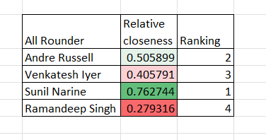

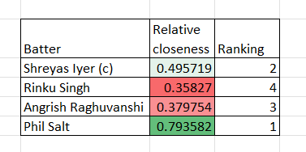

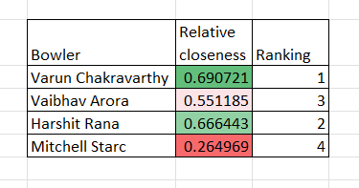

The final six players that were retained in the team were:
Sunil Narine (All-rounder, Overseas)
Andre Russell (All-rounder, Overseas)
Phil Salt (Keeper-batter, Overseas)
Shreyas Iyer (Batter, Indian)
Varun Chakravarthy (Bowler, Indian)
Harshit Rana (Bowler, Indian)

The remaining squad was selected using the BIP model.
A pool of 50 players each were made from each category of batter, bowler and all
rounders available.
The decision variable was assigned as binary, indicating whether the player was selected.

For Batters:
The objective was to maximize the efficiency which calculated as the sumproduct of the batting average and strike rate of the selected players. Constraints related to cost, number of players were also added. By solving with the help of solver the following 6 batters were selected

Sl. No. | Players Selected | Nationality
1 | Jake Fraser-McGurk | International
2 | Abishek Porel | National
3 | Nitish Kumar Reddy | National
4 | Rachin Ravindra | International
5 | MS Dhoni | National
6 | Naman Dhir | National

For Bowlers:
The same constraints as for the batters were used with a change in efficiency which was calculated as the sumproduct of bowling average and economy of the bowlers. However since this needs to be minimum for bowlers the objective was to minimize this. By solving with the help of solver the following 5 batters were selected.

Sl. No. | Players Selected | Nationality
1 | Yuzvendra Chahal | National
2 | Mohammed Siraj | National
3 | Chetan Sakariya | National
4 | T Natarajan | National
5 | Sandeep Sharma | National

For all rounders:
Here the change was made in the objective functions and the objective was to maximize the impact points of the selected players and by applying the cost and count constraints. By solving with the help of solver the following 5 batters were selected.

Sl No | Players | Nationality
1 | Daryl Mitchell | International
2 | Mitchell Marsh | International
3 | Shah Rukh Khan | National
4 | Rachin Ravindra | International
5 | Raj Angad Bawa | National
6 | Vivrant Sharma | National

Questions from the Case:
1. What key factors should KKR consider when deciding which players to retain for IPL 2025?
Answer: The team should evaluate players based on performance metrics such as batting average, strike rate, bowling economy, consistency, and impact points from the previous season. Financial factors like auction prices and the budget for different categories (batsmen, bowlers, all-rounders) are also crucial. For instance, KKR must stay within a budget of ₹120 crores while retaining only six players, focusing on those who have consistently performed well across the season.
2. How can KKR optimize their squad with a limited budget in the IPL auction?
Answer: KKR can use a data-driven approach like the Data Envelopment Analysis (DEA) method to assess player efficiency. By assigning weights to selection criteria (age, strike rate, average, etc.), they can determine which players offer the best value for their price. For example, prioritizing players with high impact points but lower costs can provide better financial management while maintaining squad strength.
3. What is the strategic importance of player categories (batsmen, bowlers, all-rounders) in forming a balanced squad?
Answer: Ensuring a well-balanced squad requires strategically allocating the budget across categories. For instance, KKR allocated ₹21 crores for bowlers, ₹18 crores for all-rounders, and a similar budget for batsmen. This distribution helps achieve an optimal mix of roles, ensuring flexibility and adaptability during matches. The squad’s composition is crucial to maintaining a competitive edge and coping with injuries or form slumps.
4. How can KKR maximize the value from uncapped or lower-priced players?
Answer: Identifying uncapped players or those with lower auction prices who demonstrated high impact in previous seasons can be a game-changer. For example, players like Rinku Singh, who cost only ₹2 crores but delivered crucial performances, offer high ROI and flexibility in budget allocation for more prominent stars.

These questions provide a framework for exploring various business and strategic aspects of player selection, emphasizing performance metrics, financial considerations, and long-term planning. The answers highlight how KKR can use data analysis, budget management, and strategic retention to optimize their squad for IPL 2025.

